**Software Requirements Specification**



**UNIVERSITY MANAGEMENT SYSTEM**

**Submitted by:**

Name of Student: Shashwat Chand

(210934106281)

**INSTITUTE OF TECHNOLOGY & SCIENCE**

**MOHAN NAGAR, GHAZIABAD**

**Batch: 2021-2024**

**Date: 19-03-2024**

***Chapter 1 Introduction***

* 1. *Purpose*
  2. *Scope*
  3. *REFERENCES*

***Chapter 2 Overall Description***

* 1. *Product Perspective*
  2. *Product Features*

*2.2.1 Functional Requirements*

*2.2.2 Non-Functional Requirements*

* 1. *User Classes and Characteristics*

***Chapter 3 Technologies to be used***

* 1. *Overview of Front End*

### *About Java*

### *Overview of Back End*

### *About SQL*

***Chapter 4 Hardware Interface***

## *Hardware Requirements*

* 1. *Software Requirements*

***Chapter 5 Database Schema:***

**5***.1 Account table*

*5.2 Student table*

*5.3 Teacher table*

*5.4 ATTENDANCE_STUDENT Table*

*5.5 ATTENDANCE_TEACHER Table*

*5.6 Subject table*

*5.7 marks table*

*5.8 Fee table*

***Chapter 6 TESTING***

*6.1Unit Testing*

*6.2 Integration Testing*

*6.3 User Acceptance*

***Chapter 7 Architectural Design***

* 1. *REQUIREMENT ANALYSIS*

## *E-R DIAGRAM*

## *7.1.2 SCHEMA DIAGRAM*

## *Chapter 8 Test Cases*

## *Chapter 9 Use case diagram*

*9.1 Splash Screen*

*9.2 Login page*

*9.3 Project page*

*9.4 New teachers/Student details*

*9.5 Apply leave*

*9.6 Fee details*

*9.7 About*

**1 Introduction**

* 1. **Purpose**

Implementing a streamlined, user-friendly self-service system that integrates seamlessly with online applications, eliminates duplicate data entry, automates academic/examination/administration operations, and provides robust monitoring and decision support for enhanced operational efficiency and accurate reporting.

* 1. **Scope**

This project deals with the various functioning in College management process. The main idea is to implement a proper process to system. In our existing system contains a many operations registration, student search, fees, attendance, exam records, performance of the student etc. All these activity takeout manually by administrator.

* 1. **REFERENCES**

**Books and Websites:**

* Internet & World Wide Web: How to Program Deitel, PJ Deitel.
* Code for Interview YouTube Channel.
* Database System Concepts, by Silberschatz, Sudarshan, and Korth.
* Fundamentals of Database Systems, RamezElmasri and Shamkant B. Navathe, 7th Edition. 2017, Pearson...

**2** **Overall Description**

**2.1 Product Perspective**

UNIVERSITY MANAGEMENT SYSTEM (UMS) is a flagship product of Easy Solution which covers all aspects of Universities, Colleges or Schools. UMS covers every minute aspects of a universities work flow and integrates all processes with user friendly interface. With hundreds of satisfied customers UMS is first choice of several state, governments/semi- government universities and institutions. UMS is an outcome of hard work done by our expert technical team in supervision of several renowned educationists which includes Controller of examination, faculties. UMS is a rare combination of experience and precision. UMS streamline path of information flow in organization by taking care of following departments:

* 1. **Product Features**
* Fee Department
* Examination Department
* Attendance
* Faculty information portal
* Student information portal
  + 1. **Functional Requirements**
* **User Authentication and Access Control:** Implement login mechanisms and access controls for different user roles.
* **Student Management:** Capture and manage student information, enrollment, course registration, and fee payments.
* **Faculty Management:** Maintain faculty profiles, course assignments, grading, and communication with students.
* **Course Management:** Create and manage course catalogs, schedules, faculty assignments, and curriculum updates.
* **Examination and Grading:** Schedule exams, generate hall tickets, record Results, calculate grades, and manage transcripts.
  + 1. **Non Functional Requirements**
* **Performance:** Ensure quick response times and handle concurrent users efficiently.
* **Scalability:** Accommodate growth in data, users, and functionalities without performance issues.
* **Reliability:** Minimize downtime and handle errors effectively for continuous operation.
* **Security:** Implement strong data encryption, access controls, and authentication mechanisms.
* **Usability:** Design an intuitive and accessible user interface for diverse users.
* **Availability:** Ensure 24/7 availability with backup and recovery mechanisms.
  1. **User Classes and Characteristics**
* **Administrators:** Manage system settings, user roles, data security, and generate reports.
* **Faculty Members:** Handle course content, assignments, grades, schedules, and student communication.
* **Students:** Access course materials, register for classes, view grades, pay fees, and communicate with faculty.
* **Admissions Staff:** Manage applications, admissions decisions, and communication with prospective students.
* **Financial Staff:** Handle financial transactions, tuition payments, scholarships, budgeting, and reporting.
* **IT Administrators:** Manage system maintenance, updates, security, integration, and provide technical support.
* **External Stakeholders:** Potentially interact for alumni services, employer partnerships, accreditation, and compliance.

1. **Technologies to be used:**

## 3.1 Overview of Front End

An important issue for the development of a project is the selection of suitable front- end and back-end. When we decided to develop the project we went through an extensive study to determine the most suitable platform that suits the needs of the organization as well as helps in development of the project.

The aspects of our study included the following factors. Front-end selection:

1. It must have a graphical user interface that assists employees that are not from IT background.
2. Scalability and extensibility.
3. Flexibility.
4. Robustness.
5. According to the organization requirement and the culture.
6. Must provide excellent reporting features with good printing support.
7. Platform independent.
8. Easy to debug and maintain.
9. Event driven programming facility.
10. Front end must support some popular back end like MySQL.

According to the above stated features we selected PHP and CSS as the front-end for developing.

### About Java:

Java is a general-purpose, class-based, object-oriented programming language designed for having lesser implementation dependencies. It is a computing platform for application development. Java is fast, secure, and reliable, therefore. It is widely used for developing Java applications in laptops, data centers, game consoles, scientific supercomputers, cell phones, etc.

**Here are some important Java applications:**

* It is used for developing Android Apps
* Helps you to create Enterprise Software
* Wide range of Mobile java Applications
* Scientific Computing Applications
* Use for Big Data Analytics
* Java Programming of Hardware devices
* Used for Server-Side Technologies like Apache, JBoss, GlassFish, etc.

## Overview of Back End

Back End Selection:

1. Multiple user support.
2. Efficient data handling.
3. Provide inherent features for security.
4. Efficient data retrieval and maintenance.
5. Stored procedures.
6. Popularity.
7. Operating System compatible.
8. Easy to install.
9. Various drivers must be available.
10. Easy to implant with the Front-end.

According to above stated features we selected MySQL as the backend.

The technical feasibility is frequently the most difficult area encountered at this stage. It is essential that the process of analysis and definition be conducted in parallel with an assessment to technical feasibility. It centers on the existing computer system (hardware, software etc.) and to what extent it can support the proposed system.

### About SQL:

SQL is Structured Query Language, which is a computer language for storing, manipulating and retrieving data stored in a relational database.

SQL is the standard language for Relational Database System. All the Relational Database Management Systems (RDMS) like MySQL, MS Access, Oracle, Sybase, Informix, Postgres and SQL Server use SQL as their standard database language.

MySQL is a fast, easy-to-use RDBMS being used for many small and big businesses. MySQL is developed, marketed and supported by MySQL AB, which is a Swedish company. MySQL is becoming so popular because of many good reasons.[1]

MySQL is released under an open-source license. So you have nothing to pay to use it. MySQL is a very powerful program in its own right. It handles a large subset of the functionality of the most expensive and powerful database packages. MySQL uses a standard form of the well-known SQL data language. MySQL works on many operating systems and with many languages including PHP, PERL, C, C++, JAVA, etc.

MySQL works very quickly and works well even with large data sets. MySQL is very friendly to PHP, the most appreciated language for web development. MySQL supports large databases, up to 50 million rows or more in a table. The default file size limit for a table is 4GB, but you can increase this (if your operating system can handle it) to a theoretical limit of 8 million terabytes (TB).

Also, they are using different dialects, such as −

* Oracle using PL/SQL,.
* SQL is widely popular because it offers the following advantages −
* Allows users to access data in the database management systems.
* Allows users to describe the data.relational
* Allows users to define the data in a database and manipulate that data.
* Allows to embed within other languages using SQL modules, libraries & pre-compilers.
* Allows users to create and drop databases and tables.
* Allows users to create view, stored procedure, functions in a database.
* Allows users to set permissions on tables, procedures and views.

1. **Hardware Interface:**

## Hardware Requirements :

|  |  |
| --- | --- |
| Processor Brand | : Intel |
| Processor Type | : Core i3 |
| Processor Speed | : 2 GHz |
| Processor Count | : 1 |
| RAM Size | : 2 GB |
| Memory Technology | : DDR3 |
| Computer Memory Type | : DDR3 SDRAM |
| Hard Drive Size | : 160 GB |

* 1. **Software Requirements :**

Operating system : Windows 10

Application server : JAVA (NetBeans)

Front end : JAVA

Connectivity : JDBC Driver

Database connectivity : WAMP (MYSQL Console)

# CHAPTER 5

**TABLE DESCRIPTION**

## 5.1 Database Design

### ACCOUNT TABLE

**Account Table**: Account table consists of five attributes which are Username, Name, Password, Sec_ques, Sec_ans.Username is used as Primary key.

Desc account;

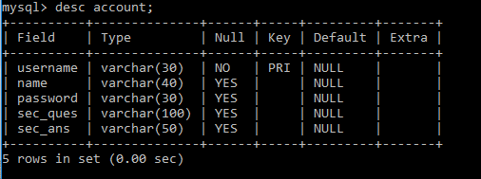

### Fig 5.1 Account table description

**5.2 STUDENT TABLE**

**Student table :**Student table is used to add the details of new student like Name, Phone no.,DoB,course,Branch etc...Phone no. ,E-mail and Aadhar are used as Primary key.

Desc student;

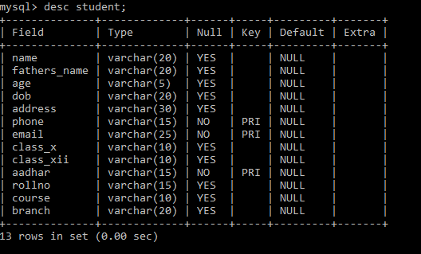

### Fig 5.2 Student table description.

**5.3 TEACHER TABLE**

**Teacher table:** Teacher table is used to add the details of new student like Name, phoneno.,DoB, course,Branch etc...Phoneno. ,E-mail and Aadhar are used as Primary key.

Desc teacher;

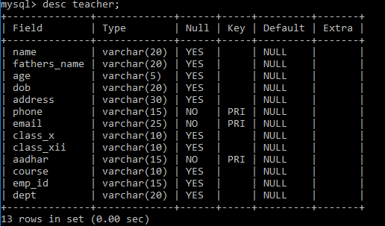

### Fig 5.3 Teacher table description

**5.4 ATTENDANCE_STUDENT TABLE**

**Attendance Student Table:** Attendance Student table is used to mark the attendance of the student day to day which as attributes like rollno,name,first and second half.

Desc attendance student;

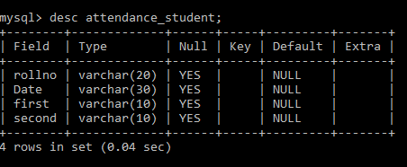

### Fig 5.4 Attendance_Student table description.

**5.5 ATTENDANCE_TEACHER TABLE**

**Attendance_Teachertable :**Attendance Teacher table is used to mark the attendance of the teacher day to day which as attributes like emp_id,name,first and second half.

Desc attendance_teacher;

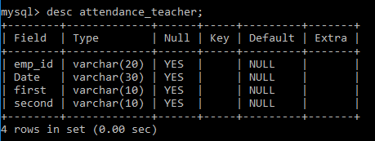

### Fig 5.5 Attendance_Teacher table description.

**5.6 SUBJECT TABLE**

**Subject table :**Subject table is used to add the subjects of the student in that particular sem with the attributes like rollno and five subjects.

Desc Subject;

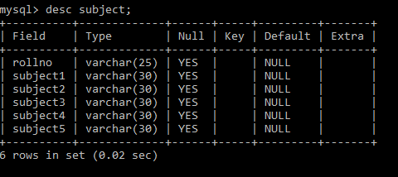

### Fig 5.6 Subject table description.

**5.7 MARKS TABLE**

**Marks table :**Marks table is used to add the marks of the particular subjects of the student in a particular sem and the attributes used are rollno and five subject marks.

Desc Marks;

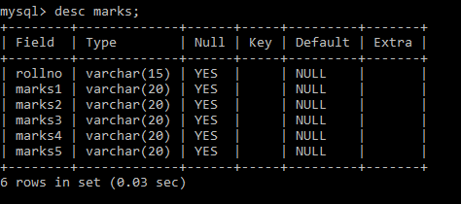

### Fig 5.7 Marks table description.

**5.8 FEE TABLE**

**Fee table:**fee table is used to pay the fee dues of the student for that particular sem and the attributes used like rollno, name, fathersname, course, branch, sem and fee_paid.

Desc Fee;

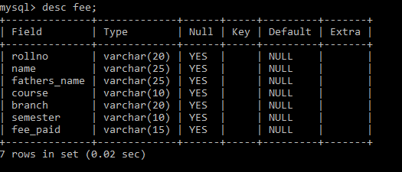

**Fig 5.8 Fee table description.**

**6 TESTING**

System testing is the stage of implementation, which is aimed at ensuring that the system works accurately and efficiently before live operation commences. Testing is the process of executing the program with the intent of finding errors and missing operations and also a complete verification to determine whether the objectives are met and the user requirements are satisfied. The ultimate aim is quality assurance.

## Unit Testing

The software units in a system are modules and routines that are assembled and integrated to perform a specific function. Unit testing focuses first on modules, independently of one another, to locate errors. This enables, to detect errors in coding and logic that are contained within each module. This testing includes entering data and ascertaining if the value matches to the type and size supported by java. The various controls are tested to ensure that each performs its action as required.

## Integration Testing

Data can be lost across any interface, one module can have an adverse effect on another, sub functions when combined, may not produce the desired major functions. Integration testing is a systematic testing to discover errors associated within the interface. The objective is to take unit tested modules and build a program structure. All the modules are combined and tested as a whole. Here the Server module and Client module options are integrated and tested. This testing provides the assurance that the application is well integrated functional unit with smooth transition of data.

## User Acceptance

Testing User acceptance of a system is the key factor for the success of any system. The system under consideration is tested for user acceptance by constantly keeping in touch with the system users at time of developing and making changes whenever required.

1. **Architectural Design:**

**7.1 REQUIREMENT ANALYSIS**

## E-R DIAGRAM:

**ER Diagram:** ER Diagram is a high-level conceptual data model diagram. Entity-Relation model is based on the notion of real-world entities and the relationship between them. ER modelling helps you to analyse data requirements systematically to produce a well-designed database.

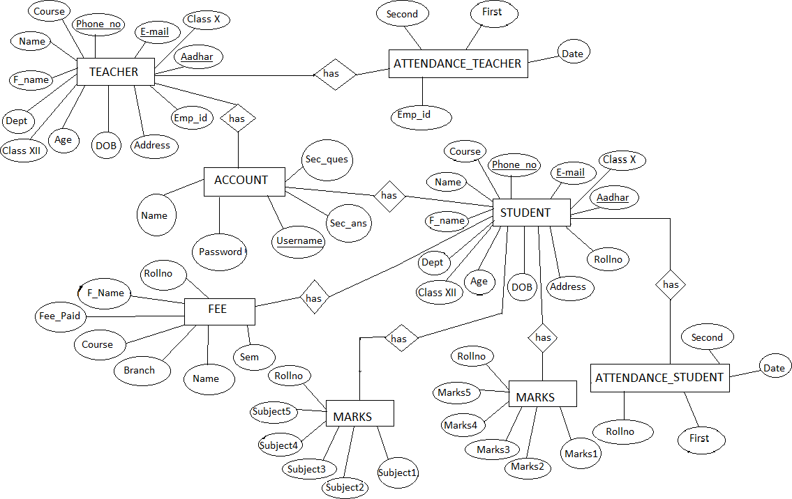

## 7.1.2 SCHEMA DIAGRAM:

**Schema diagram** A schema diagram is the skeleton structure that represents the logical view of the entire database. It contains a descriptive detail of the database.

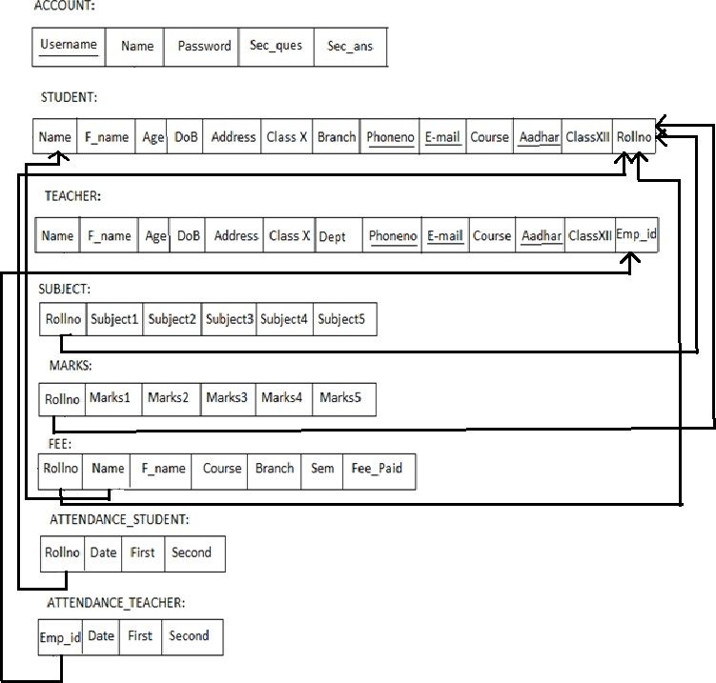

## Test Cases:

**Table 1 Test cases**

|  |  |  |  |  |  |
| --- | --- | --- | --- | --- | --- |
| **Test No.** | **Test Name** | **input** | **Actual output** | **Expected output** | **Status** |
| 1 | Login | Username and password | User is  successfully Authenticated | User is  successfully Authenticated | Pass |
| 2 | Login | Wrong username and  password | Invalid username or  password | Invalid username or  password | Pass |
| 3 | Signup | User details and  passsword | Account successfully  created | Account successfully  created | Pass |
| 4 | Student | Details of the  student required. | Student  inserted successfully | Student  inserted successfully | Pass |
| 5 | Teacher | Details of the  teacher required | Teacher  inserted successfully | Teacher  inserted successfully | Pass |
| 6 | Subject | Enter the subject names and marks along with  rollno | Subjects entered successfully | Subjects entered successfully | Pass |
| 7 | Fee | Details and fee_paid | Paid successfully | Paid successfully | Pass |
| 8 | Remove Student | Enter rollno and click on  remove | Removed successfully | Removed successfully | Pass |
| 9 | Remove Teacher | Enter emp_id and click on  remove | Teacher removed  successfully | Teacher removed  successfully | Pass |
| 10 | Exit | Click on Exit | Logout successfully | Logout successfully | Pass |

## Use case diagrams:

## Splash Screen

## C:\Users\shash\Pictures\Screenshots\Screenshot 2024-03-26 104108.png

## Login page

## C:\Users\shash\Pictures\Screenshots\Screenshot 2024-03-26 104219.png

## Project page

## C:\Users\shash\Pictures\Screenshots\Screenshot 2024-03-26 104249.png

## New teacher/Student Details

## C:\Users\shash\Pictures\Screenshots\Screenshot 2024-03-26 104351.png

## Apply Leave

## C:\Users\shash\Pictures\Screenshots\Screenshot 2024-03-26 104521.png

## Fee details

## C:\Users\shash\Pictures\Screenshots\Screenshot 2024-03-26 104558.png

## About

## C:\Users\shash\Pictures\Screenshots\Screenshot 2024-03-26 104542.png